**Project Design Phase-II**

**Technology Stack (Architecture & Stack)**

|  |  |
| --- | --- |
| Date | 13 October 2022 |
| Team ID | B2-2M4E |
| Project Name | Smart waste management system for metropolitian cities. |
| Maximum Marks | 4 Marks |

**Technical Architecture:**

The Deliverable shall include the architectural diagram as below and the information as per the table1

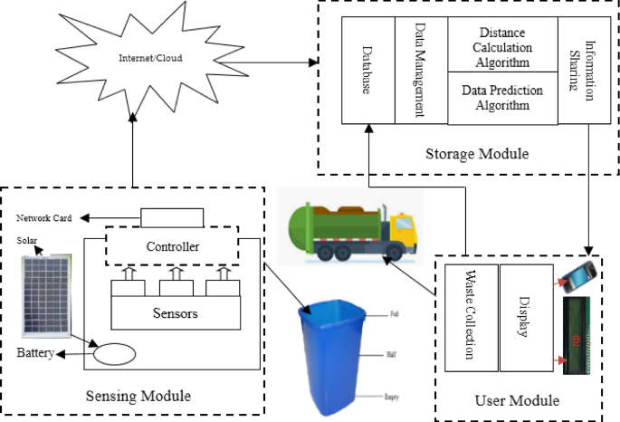

**Table-1 :Hardware And Software Components.**

|  |  |  |
| --- | --- | --- |
| **S.No** | **Component** | **Description** |
|  | Ultrasonic sensor | To detect the obstacles. |
|  | Node MCU | Provides internet access. |
|  | Arduino | Dual purpose of supplying power and acting as a serial port to interface arduino and computer. |
|  | Arduino IDE | Includes text editor for writing code,text field, a console a basic feature button toolbar and a set of menus. |
|  | Database | Data Type, Configurations etc. |
|  | Tinkercad | It is an online compilation of autodesk software resource.  Offers circuit modelling facilites. |
|  | Thing speak | Open-source for internet of things. |
|  | IFTTT | Web based application. |
|  | LoRa | Transmit garbage level data |
|  | Solar pannel | Recharges the battery. |